Naples FL 727-389-3897 www.bestjetsusa.net barbara@bestjetsusa.net or dtaylor3282@gmail.com
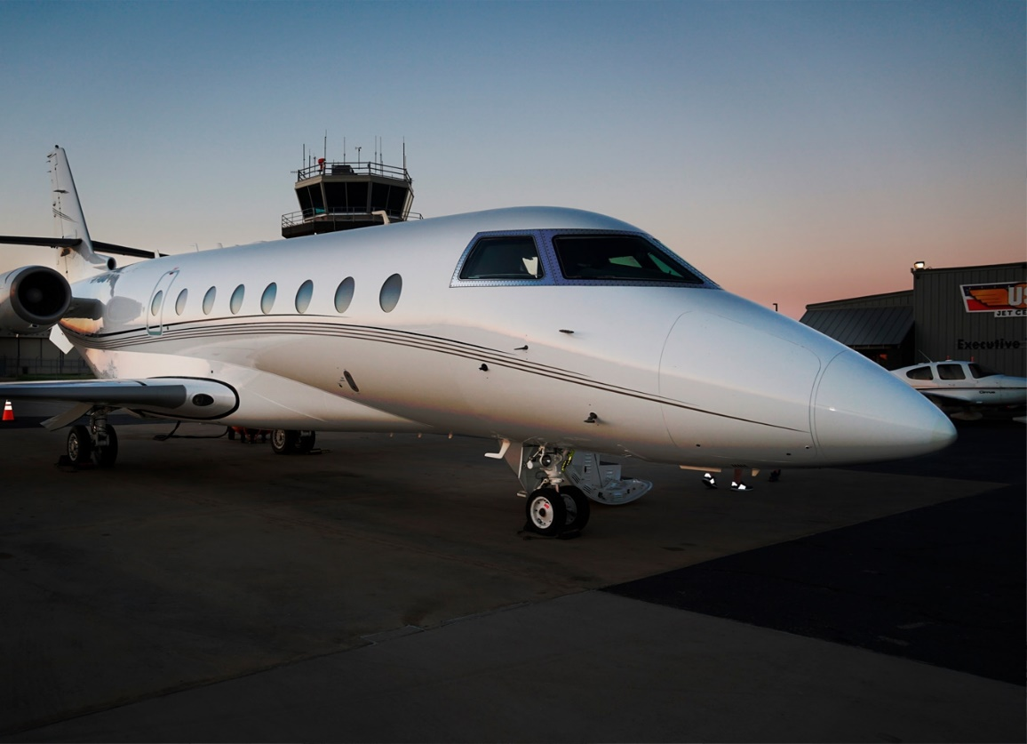

2002 Gulfstream G200

Airframe TT: 5,623
Landings: 3,147
APU: 3,100
GTPC 36-150

Avionics:
ADF Dual Collins
AFIS Honeywell
Radios: Dual Collins VHF-422D’s
Auto Pilot: Dual Collins FCC-4005 IFCS
CVR: Universal CVR-120
EFIS: Collins Five Tube
FMS: FMS-6100 with dual GPS
Dual Bendix King KHF-950 w/ Motorola SELCAL
IRS: Honeywell LASEREF IV
Nav Radios: Dual Collins 432
SAT COM: Aircell Axxcess w/ three handsets
TAWS: Allied Signal Mark V EGpws w/RAAS
TCAS: TCAS II w/change 7.1
Dual Mode S Transponders
Weather Radar WXR-850 color with turbulence
Traffic Avoidance
TR’s
APU
Terrain Awareness & Warning System
Part 135
Recent Deice Boots

Maintenance:
16C completed June 2019
4 C due June 2023

Price: 5.5M
Barbara Taylor
Best Jets Inc
727-389-3897
barbara@bestjetsusa.net

